

**LA GRANDEE INTERNATIONAL COLLEGE**

**Simalchaur, Pokhara Nepal**

Final Project Report

On

**“Job Nexus”**

(Online Job Portal Application)

**Submitted to:**

Bachelor of Computer Application (BCA) Program

In partial fulfilment of the requirements for the degree of BCA under

Pokhara University

**Submitted by:**

|  |  |  |  |
| --- | --- | --- | --- |
| **Name:** | **Course** | **Semester** | **P.U. Registration Number** |
| Akriti Chapagain | BCA | 6th | 2019-01-53-0104 |
| Binaya Koirala | BCA | 6th | 2019-01-53-0111 |

**Date:29/06/2024**

**Acknowledgement**

We would like to express our gratitude to Pokhara University for developing a highly valuable curriculum and enabling us to undertake this project. Furthermore, we extend our sincere appreciation to LA GRANDEE International College, whose assistance has been instrumental in making our project a reality. Without their support, our project would have been unattainable. We express our sincere regard to our project supervisor **Mr.Sunil Sapkota,** for his valuable time, guidance, encouragement, support, and cooperation throughout the duration of our project. We would sincerely like to thank **BCA** Department for giving us the opportunity to work on enhancing our technical skills while undergoing this project. This project helped us understand the various parameters involved in the development of a mobile application and the working and integration of frontend along with the backend to create a fully functional mobile application.

With Regards,

Akriti Chapgain (Registration No: 2019-1-53-0104)

Binaya koirala (Registration No: 2019-1-53-0111)

**DECLARATION FOR**

**“Job Nexus”**

**STUDENT’S DECLARATION**

We hereby declare that we are the only authors of this work and that no sources other than the mentioned here have been used in this. We assure you that the work we present here is unique to ourselves and resemblances to another similar project are purely coincidental.

Akriti Chapagai (PU Exam Roll no): 20530162

Binaya Koirala (PU Exam Roll no): 20530169

Program: BCA, 6th Semester

Date: 29/06/2024

**Supervisor’s Declaration**

I hereby recommend that this project entitled **“Job Nexus”** is done under my supervision by **Akriti Chapagain** and **Binaya Koirala** during their 6thSemester in partial fulfilment of the requirements for the degree of BCA under **Pokhara University** is completed to my satisfaction and be processed for final evaluation.

____________________________

Mr. Sunil Sapkota

Supervisior

Date:____ / ____ / ________

**Letter of Approval**

We certify that we have examined this report entitled “FundFusion” and are satisfied with the project defense. In our opinion, it is satisfactory in the scope and qualifies as a project in partial fulfillment of the requirements for the degree of BCA (Bachelor in Computer Application) under **Pokhara University.**

|  |  |  |
| --- | --- | --- |
| ________________________  **Supervisor**  Er. Sunil Pandey | _________________  **Examiner**  **Date:29/06/2024** | ________________________  **Program Coordinator**  Ramesh Chalise |
|  |  |  |

# ABSTRACT

The project, titled "Job Nexus," offers an in-depth exploration of the development and functionality of a comprehensive Job Portal App. "Job Nexus" is designed to facilitate an interactive job vacancy form for employees, effectively gathering and categorizing employer and employee information based on specific job requirements and available vacancies. The unique development methodology employed in "Job Nexus" ensures efficient acquisition and organization of both employer and employee data. This system categorizes individuals according to their qualifications, skills, and job preferences, while also matching them with relevant job vacancies. The application provides detailed information about job opportunities and allows employers to leverage the platform's services. Registered employers gain access to a suite of features, including the ability to publish vacancy details, search for potential employees, and filter candidates based on key skills provided during registration. This enhances the recruitment process by allowing employers to find the most suitable candidates efficiently. Through "Job Nexus," job seekers can also browse and apply for jobs that match their skills and career aspirations, fostering a more dynamic and interactive job market.

**TABLE OF CONTENTS**

1. INTRODUCTION 1

2. PROBLEM STATEMENT 2

3. OBJECTIVES 3

4. BACKGROUND STUDY 4

5. LITERATURE REVIEW 5

6. METHODOLOGY 7

7. SYSTEM DESIGN 8

8. GANTT CHART 11

9. DATABASE SCHEMA: 12

10. TESTING METHODOLOGY 13

11. PROJECT RESULTS 14

12. FUTURE ENHANCEMNTS 15

13. CONCLUSION 16

14. REFRENCES 17

15. TEST CASES 20

**TABLE OF FIGURES**

Figure 1: Agile Methodology for Development of FundFusion 7

Figure 2: DFD level-1 for FundFusion 8

Figure 3: Flowchart from the perspective of User. 9

Figure 4: Flowchart from the perspective of Admin. 10

Figure 5: Database Schema for FundFusion 12

Figure 6: Gantt Chart for FundFusion 11

**LIST OF ABBREVIATIONS:**

|  |  |
| --- | --- |
| API | Application programming interface |
| BCA | Bachelor of computer Applications |
| CI/CD | Continuous improvement /Continuous development |
| DFD | Data flow Diagram |
| ER | Entity Relationship |
| SDLC | Software Development Life Cycle |
| SQL | Structure Query Language |
| NPM | Node package Manager |
| EG | EXAMPLE |
| PHP | Hypertext Preprocessor |
| IDE | Integrated Development Environment |

# INTRODUCTION

Job Nexus, a mobile application, is set to revolutionize the job search process in Nepal. Job Nexus establishes partnerships with local organizations to facilitate the provision of vacancies for semi-skilled manpower, as well as opportunities for individuals seeking entry-level positions. This strategic collaboration ensures that Job Nexus offers opportunities to a diverse range of job seekers, including those with varying levels of skills and experience. Leveraging these partnerships, Job Nexus broadens job access and provides opportunities for individuals in rural regions and local communities.

The job market in Nepal, much like in many developing countries, is characterized by a significant gap between job seekers and job providers. Many job seekers, particularly those from rural areas and those with minimal skills, face difficulties in accessing job opportunities. On the other hand, employers often struggle to find suitable candidates for their vacancies. The rise of technology and mobile applications presents an opportunity to bridge this gap effectively. By offering a platform that connects job seekers with a wide array of job opportunities, including roles that require minimal skills, Job Nexus plays a crucial role in promoting inclusivity and economic empowerment. Job Nexus simplifies the job search process for both candidates and employers. Job seekers have the ability to easily upload their resumes and explore job openings matched to their profiles, while employers benefit from simplified job posting and application management. Furthermore, Job Nexus is committed to strengthening skill development and professional growth. By creating a unified platform for training programs and volunteer opportunities, Job Nexus empowers individuals to enhance their skills and access new career opportunities.

This application is using technologies such as React Native for frontend development and Laravel for backend, along with various tools and utilities to ensure easy and flawless navigation. This enabled Job Nexus to serve as a beacon for candidates searching for job opportunities and an asset for those who benefited from this application. The purpose of the "JobNexus" project is to develop a comprehensive job portal application that addresses these challenges by providing a seamless platform for job seekers and employers to connect.The significance of "JobNexus" lies in its potential to revolutionize the job search process in Nepal. By addressing the gaps in the current job market, the application promotes economic empowerment and inclusivity..

# PROBLEM STATEMENT

Following were the problems we found in hob portal applications:

* Job seekers encounter difficulties finding appropriate roles because of insufficient skill-based matching on existing platforms.
* Semiskilled workers, like plumbers and construction workers, confront a scarcity of job listings as portals primarily prioritize skilled positions.
* In the absence of dedicated platforms, there's a notable gap for registering volunteers during events, leaving organizers without efficient means to manage manpower.
* There aren't many apps that bring together different training and workshop programs, making it hard for people to find skill-building opportunities.
* Current job portals in Nepal lack collaborations with local businesses, hindering job access, particularly in rural region.

# OBJECTIVES

* To establish collaborations with local businesses to broaden job access and ensure rural inclusion and semi-skilled job potentials.
* To implement advance filter to better match job seekers with suitable roles based on their skills.
* To create a unified platform for users to easily find and enroll in diverse training programs, volunteers, fostering skill development.

# BACKGROUND STUDY

After conducting extensive research on the internet, we identified a few theories on online job portals. In a study conducted by Nameirakpam Chetana, it was observed that job seekers exhibits positive mindset towards utilizing online recruitment for job opportunities. The factors considered in this context included cost-effectiveness, time efficiency, extensive search capabilities, reliability of information, and the security and confidentiality of data. These factors significantly influence jobseekers' choices of job portals. The research noted that professionals with diverse backgrounds hold different perspectives on the cost-effectiveness, reliability, and security of online job recruitment platforms. The study also emphasized that safety and reliability are crucial concerns for both job seekers and existing employees when engaging with online recruitment portals.[3] Dilusha Madushanka Liyanage and Bandula Lanka Galhena highlighted that many companies now prefer electronic recruitment (e-recruitment) over traditional methods for hiring employees. Furthermore, prospective job applicants show a growing interest in searching for and applying to job openings through the internet. To attract a suitable pool of applicants, organizations strive to develop attractive, content-rich, easy-to-use, and user-friendly recruitment processes, either through their own career websites or via job portals. [4]

According to Anshika Saxena and Dr. Mamta Gaur , it was concluded that e-recruitment is reducing the traditional methods of recruitment. Job seekers prefer online job portalsfor the purpose of applying and searching for jobs over the internet. There are various factors which influence the perception of jobseekers for using job portals like convenience, efficiency, productivity, user friendliness, accurate information and security. It is a time saving & cost effective method for job seekers. It was also concluded that the services offered by job portals are effective and it provides many other benefits to the candidate’s like resume building, future career opportunities, and providing information frequently and timely. In the jobseekers perception online job portals are effective and convenient tools. [5]

**Literature Review**

The days of searching the newspaper for job openings are long gone. Online job portals are an essential tool for any job seeker. They enable you to find the ideal job and ensure that you do not miss out on a good opportunity. There are numerous Job Portals in Nepal these days that provide comprehensive information about jobs, including vacancy notifications and employment opportunities. They make it simple to search for jobs, upload your resume, and apply for them. Now-a-days the job market is so extensive that a variety of industries and companies are searching for the right candidates and the prospective candidates are searching for the right companies for growth opportunities. This purpose is served by most of the job portals online. The intention of Job Portal is to facilitate both the candidates seeking jobs as well as the employers looking for employees for their companies. Any job seeker can search for the available jobs at any moment with updated information. When he finds a job, he can post his application to the job online. Employers can advertise the vacancies by taking the membership, logging in and posting the job information with the eligibility criteria for the jobs. [6]

One of the approaches to enhance work portability is to give online job offer administrations. Online job portals can help jobseekers as they contain all required data about accessible openings in a solitary point. Such portals upgrade effectiveness in job recruitment as candidates can coordinate their capabilities and skills to the prerequisites of bosses. [7] In India, the rate of unemployment has been increasing rapidly since the 2000s. Dorn and Naz [8] mentioned that one reason for this problem is the unfair distribution or absence of information on job openings, so people cannot know the latest job vacancies. It means that there are jobs available, but job-seekers do not have access to that data. An effective search of the internet might help job seekers in their job hunt. Some web portals provide an efficient way to search the web for online information on job vacancies for job-seekers [9].

**Study of existing systems**

Nepal’s job market is diverse, encompassing a range of sectors including agriculture, manufacturing, services, and more recently, technology and tourism. Despite this diversity, the market faces several challenges:

**High Unemployment Rate:** According to the Central Bureau of Statistics Nepal, the unemployment rate has been fluctuating, with youth unemployment particularly high. Many graduates are unable to find jobs that match their qualifications.

**Underemployment:** A significant portion of the workforce is underemployed, meaning they are working in jobs that do not fully utilize their skills or provide adequate income.

**Rural-Urban Divide:** There is a stark contrast between job opportunities in urban centers and rural areas. Many rural job seekers migrate to cities in search of better opportunities, leading to urban overcrowding and rural depopulation.

**Lack of Access to Information:** Job seekers often lack access to timely and relevant information about job openings, especially those in rural areas. Employers also face challenges in reaching a broad pool of candidates.

**Analysis of Existing Job Portals**

Several job portals are currently operating in Nepal, each with its own strengths and limitations.

**Merojob**:

Strengths:

• One of the largest and most popular job portals in Nepal.

• Extensive database of job listings across various industries.

• User-friendly interface with advanced search options.

Limitations:

• Primarily focused on urban areas and skilled positions.

• Limited reach in rural areas and among semi-skilled workers.

**Kantipur Job:**

Strengths:

• Wide range of job listings from various sectors.

• Strong brand recognition due to association with Kantipur Media Group.

Limitations:

• User interface can be cumbersome and outdated.

• Focuses more on white-collar jobs, with less emphasis on semi-skilled and entry-level positions.

**Kumarijob**

Strengths:

• Extensive job listings and user-friendly interface.

• Good categorization of jobs by industry and job type.

Limitations:

• Limited outreach and engagement with rural job markets.

• Less emphasis on skill development and training opportunities.

After examining the current systems available, we found that none of them included an effective built-in resume generator. While a few systems claimed to offer this feature, the resumes produced were overly basic and lacked a professional touch. This situation presents an opportunity for us, as we intend to address these user challenges by providing a solution that is more flexible and user-friendly. Additionally, current systems mainly emphasize skilled jobs, neglecting individuals interested in volunteer opportunities.

# REQUIREMENT DOCUMENT

This requirement documentation outlines the functional, non-functional requirements and Tools and software requirements of Job Nexus:

**5.1 Functional Requirements**

* **User Registration and Authentication**: Enable users to register and create accounts. - Implement secure authentication methods like email/password. Provide password reset and account recovery option
* **User Profiles**: Job seekers and employers have profiles where they can manage personal information.
* **Job Listings and Applications**: Employers should be able to post job listings with details such as job title, description, requirements, location, and salary range, Job seekers should be able to browse and search job listings based on various criteria.
* **Version Control:** Integration with GitHub should be set up for version control, collaboration, and automated CI/CD workflows using GitHub Actions.
* **Backend Integration:** - Connect the app with a backend system to handle data storage, product management, order processing, and other business logic.
* **Dashboard:** The app should have an intuitive admin panel for managing user accounts and content efficiently.
* **Wish list:** Application user should be able to add some jobs in wish list for their easy access.

**5.2 Non-Functional Requirements:**

* **Compatibility:** The application must be compatible with both Android and iOS devices, providing a consistent user experience across different platforms.
* **Clean Architecture:** Follow best practices in coding by managing dependencies and documentation to ensure the system is maintainable and scalable.
* **User Interface:** The application must have an intuitive and user-friendly interface that is easy to navigate for both job seekers and employers.
* **Future Growth**: The app architecture must support future growth, allowing for easy updates and the addition of new features as needed.

**5.3 Tools and software requirements**

**Development Tools:**

* Integrated Development Environment (IDE):Visual Studio Code
* Version Control: Git (for version control)
* GitHub (platform for collaboration and code hosting)
* Database Management System:
* MySQL (for managing user data, job listings, applications, and other critical information)

**Package Manager:**

* npm (Version: 10.5.0, Node Package Manager, essential for managing dependencies and packages in React Native projects)
* Composer (Version 2.2.22): Composer automates the management of dependencies in PHP applications, ensuring consistent installation and version control.It simplifies package management, improving maintainability and reducing the risk of dependency conflicts in PHP projects

**Frontend Technology:**

React Native (built with Expo for cross-platform mobile application development for iOS and Android users)

**Backend Technology:**

Laravel (providing a robust and scalable framework for handling API requests, user authentication, job listings, and application management in PHP)

**5.4 Requirement Matrix:**

A requirement matrix, also known as a traceability matrix, is a crucial tool in project management and systems engineering. It is used to ensure that all project requirements are tracked and fulfilled throughout the project lifecycle.

|  |  |  |  |  |
| --- | --- | --- | --- | --- |
| Requirement ID | Requirement Description | Type | Priority | Status |
| FR-01 | Authentication: Users can securely register and log in to the app | Functional | High | Completed |
| FR-02 | Job seekers can apply, Add jobs to wishlist and manage their profile. | Functional | High | Completed |
| FR-03 | Employers can Post jobs, Manage job applicants such as Accepting or rejecting candidates. | Functional | High | Completed |
| FR-04 | Job seekers can apply for jobs directly through the app. | Functional | High | Completed |
| FR-05 | The app offers information about volunteer opportunities. | Functional | Medium | Completed |
| NFR-01 | Intuitive admin panel for managing user accounts and content. | Non-Functional | Medium | Completed |
| NFR-02 | The user interface must be intuitive and easy to navigate. | Non-Functional | High | Completed |
| NFR-03 | The app architecture must support future growth. | Non-Functional | High | Completed |
| NFR-04 | Data protection through encryption. | Non-Functional | High | Completed |

.

# METHODOLOGY

The Agile methodology is being used to develop the JobNexus. Agile is a flexible and iterative approach that allows for rapid development and testing. The Agile methodology is well-suited to projects with evolving requirements, such as JobNexus, where there may be changes in the features and functionalities that the platform requires. The Agile methodology will be implemented using the Scrum framework, which is a popular Agile methodology that involves working in small, cross-functional teams. The team consist of four 2 members who will each work on a specific part of the JobNexus platform. The team will meet regularly to discuss progress, plan for the next iteration, and address any issues that arise.

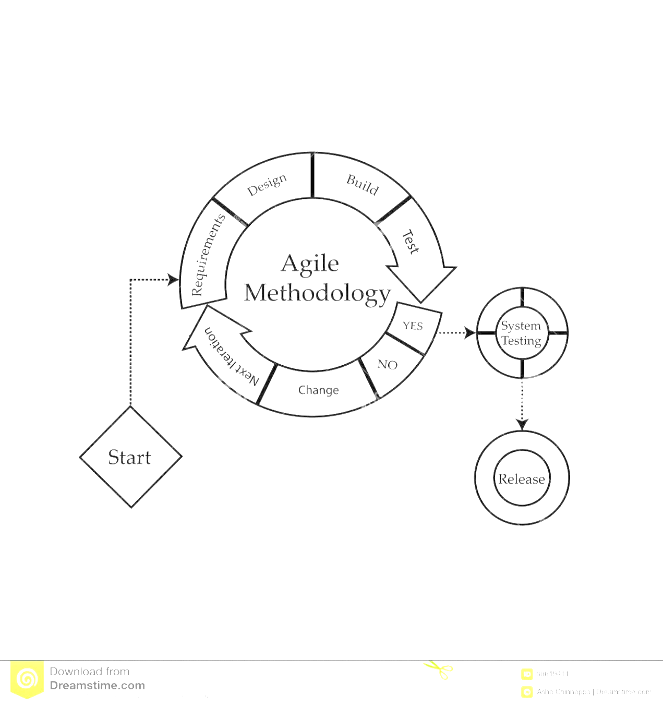

Figure 1: Agile Methodology for Development of JobNexus

**How we use agile Methodology in our project?**

**Weekly Sprints:**

**Sprint Planning**: At the beginning of each week, we conduct a sprint planning meeting to define the tasks and goals for the upcoming sprint.

**Daily Stand-ups:** Every day, we hold short stand-up meetings to discuss progress, plan the day’s work, and address any blockers.

**Sprint Review:** At the end of the week, a sprint review meeting is held where feedback is collected to ensure alignment with project goals.

**Sprint Retrospective**: Following the sprint review, a sprint retrospective meeting is conducted to reflect on what went well, what could be improved, and how processes can be optimized for the next sprint.

We are a group of 2 individual students were confined to the development of the final year project and here is the work division chart among us:

|  |  |  |  |
| --- | --- | --- | --- |
| **S.N** | Name | Work Assigned | Remarks |
| 1. | Akriti Chapagain | Week 1:   * Project Setup and Initial Components, * Welcome   Login and Signup page   * Splash Screen   Week 2:   * Employer and Employee UI * Job Listing * System Design   Week 3   * Job Application UI   Week 4:   * Employer and Employee Features   Week 5:   * UI /Ux Enhance   Week 6:   * UI Enhancement   Week 7: Documentation | Week 1: Satisfied  Week 2.  satisfied  Week 3:  Not satisfied  Week 4: Satisfied  Week 5: Not Satisfied  Week 6: Satisfied  Week 7: Satisfied |
| 2. | Binaya Koirala | Week 1:  Week 2:  Week 3:  Week 4:  Week 5:  Week 6:  Week 7: |  |

# SYSTEM DESIGN

System design is the process of defining and organizing the components and interactions of a system to fulfill specific requirements. It involves creating a blueprint or plan that outlines how the system will function and how its various parts will work together. In JobNexus commonly used tools in system design are Data Flow Diagrams (DFDs) and Flowcharts and Er diagram.

* 1. **ER Diagram:**

An ER diagram shows the relationship among entity sets. An entity set is a group of similar entities and these entities can have attributes. It helps in understanding the data flow and structure, ensuring efficient database design and data integrity.

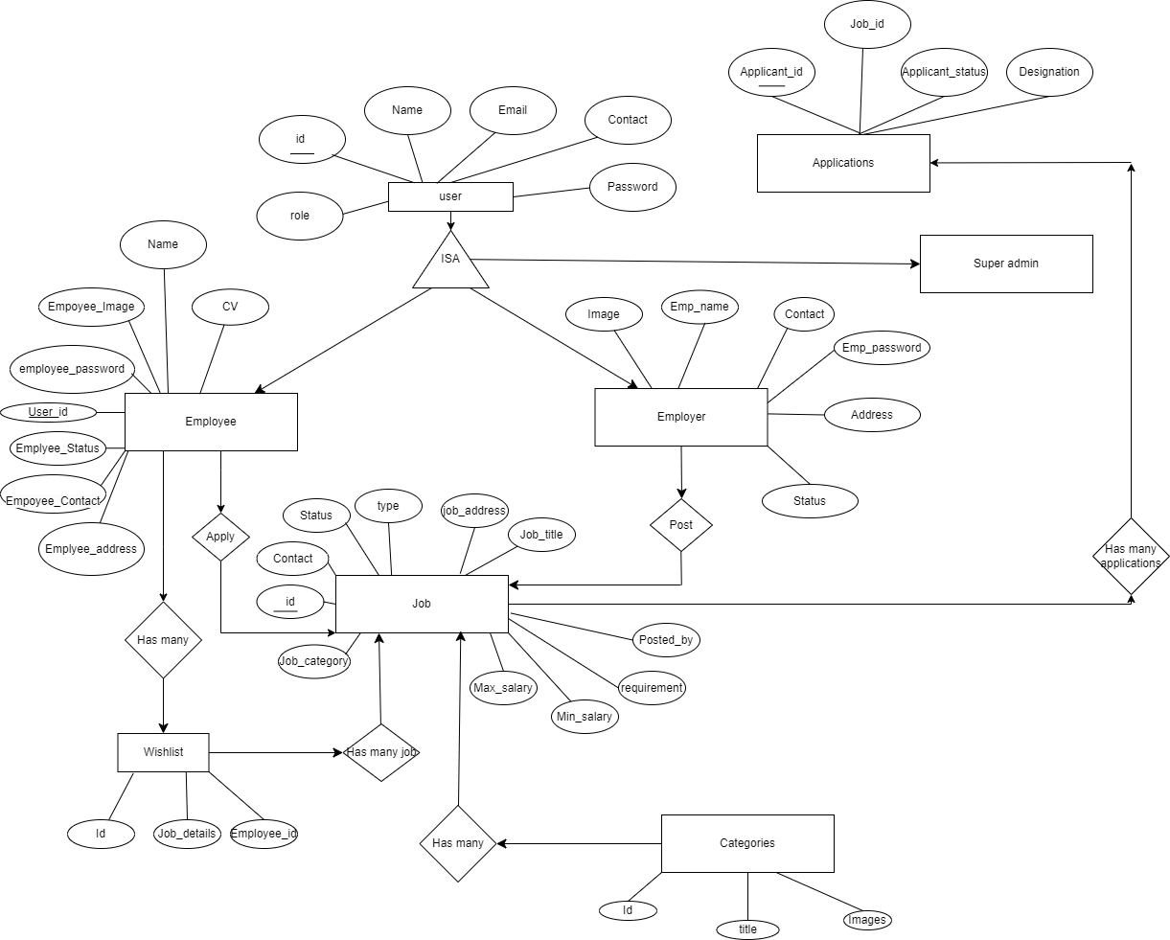

Figure 2: ER diagram

In JobNexus, the given are the major relations:

**Employer Post Job**

Employers create job listings by filling out job details, which includes Job title, job description, address, type , Minimum salary, Maximum salary, requirement etc.

**Employee Applies Job**

Employees can browse job listings and apply for jobs by submitting their applications.

**Employee Has Wishlist**

Employees can add and delete jobs to their wishlist for future reference.

* 1. **Dataflow Diagram:**

A Data Flow Diagram (DFD) is a graphical representation that shows the flow of data within a system. It consists of different components such as processes, data stores, external entities, and data flows.

**DFD level 0 Of JobNexus:**

This Level 0 DFD provides a high-level view of how the Job Nexus system operates, focusing on the interactions between employees, employers, and the admin. It highlights the core functionalities, such as job searching, application processing, job posting, and administrative oversight, ensuring that all user roles can perform their respective tasks efficiently within the platform. They provide a broad view that is easily digestible but offers little detail.

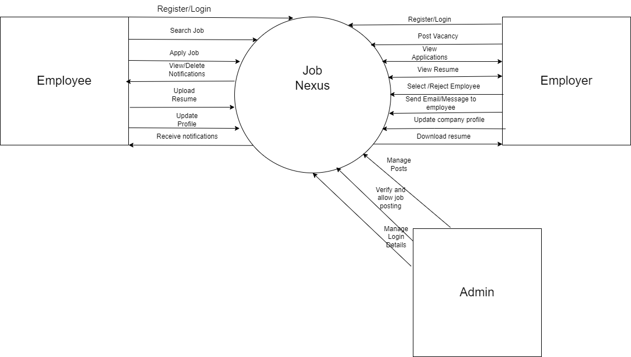

Figure 2: DFD Level 0 for JobNexus

**DFD level 1 Of JobNexus:**

Level 1 DFDs are still a general overview, but they go into more detail than a context diagram. In level 1 DFD, the single process node from the context diagram is broken down into sub-processes. JobNexus illustrates the core processes of job creation and job searching. Employers create and update job listings, which are then available for employees to view, search, and apply for. The diagram clearly shows how data flows between employees, employers, and the main processes within the Job Nexus system, ensuring efficient job matching and application management.

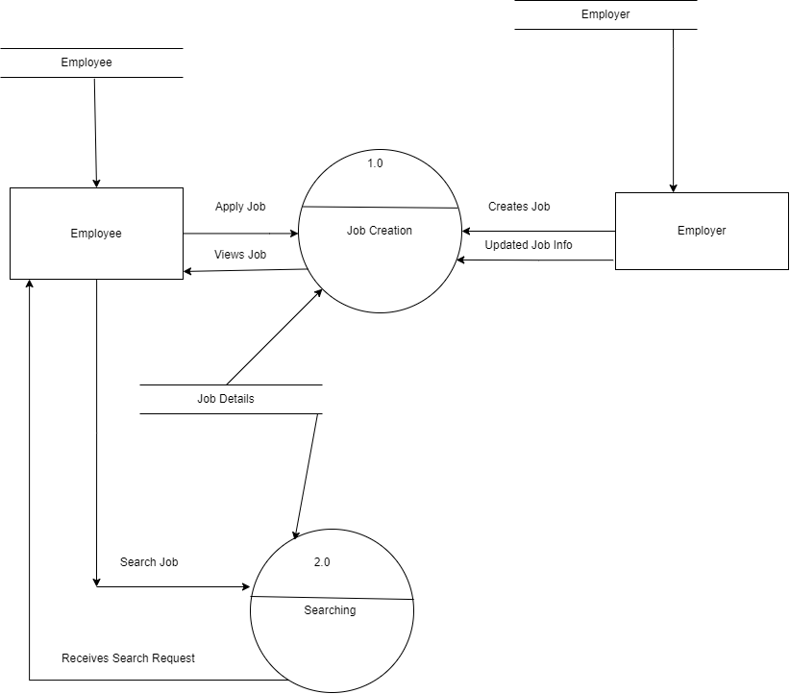

Figure 2: DFD Level 1 for JobNexus

**DFD level 2 from the perspective of Employer:**

This Level 2 DFD provides an in-depth look at the processes involved in managing job postings and applications from the employer's perspective. It breaks down the job creation, modification, viewing, and application processing steps, showing how data flows between these processes and the relevant data stores

Employers can create new job listings, update or delete existing jobs, view applications, and approve or reject applications. All these actions interact with the Job DB and Application DB to store and retrieve relevant data.

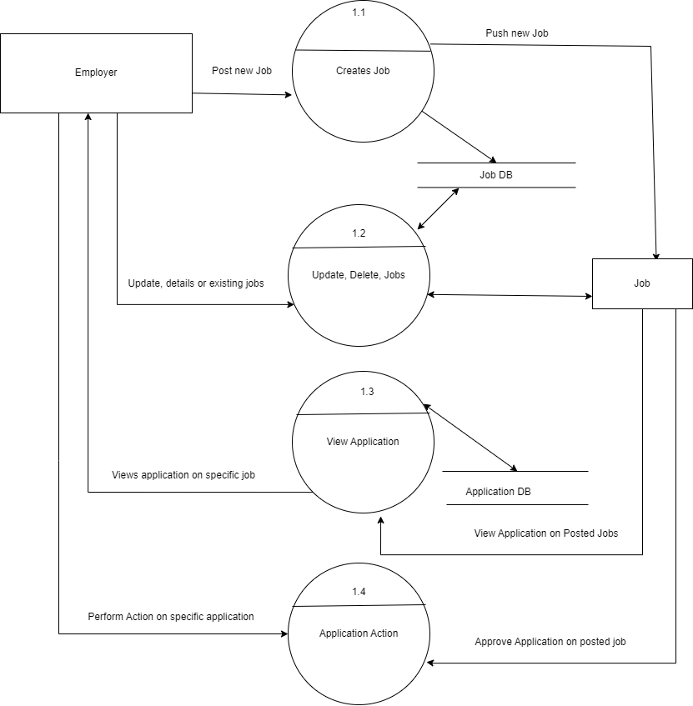

Fig:DFD level 2 from the perspective of Employer

**DFD level 2 from the perspective of Employee:**

Employees can view job listings, search for jobs, add jobs to their wishlist, and apply for jobs. These actions interact with the Job DB, Wishlist DB, and Application DB to manage and store the data appropriately.

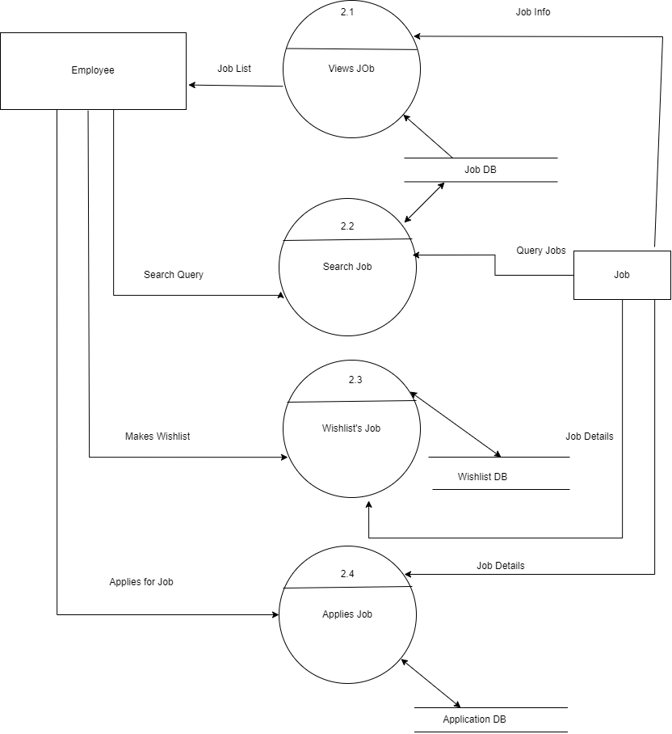

*Fig: DFD level 2 from the perspective of Employee*

* 1. **Flowchart:**

Flowchart is a graphical representation that depicts the sequential steps or actions involved process or algorithm. Here we have included flowchart digarams which includes Authentication process, Employer process and Employee process.

**Figure 1: Authentication**

This flowchart illustrates the user authentication and role determination process within the Job Nexus application. It ensures that users are properly authenticated and directed to the appropriate functionalities based on their roles, whether they are employees or employers.

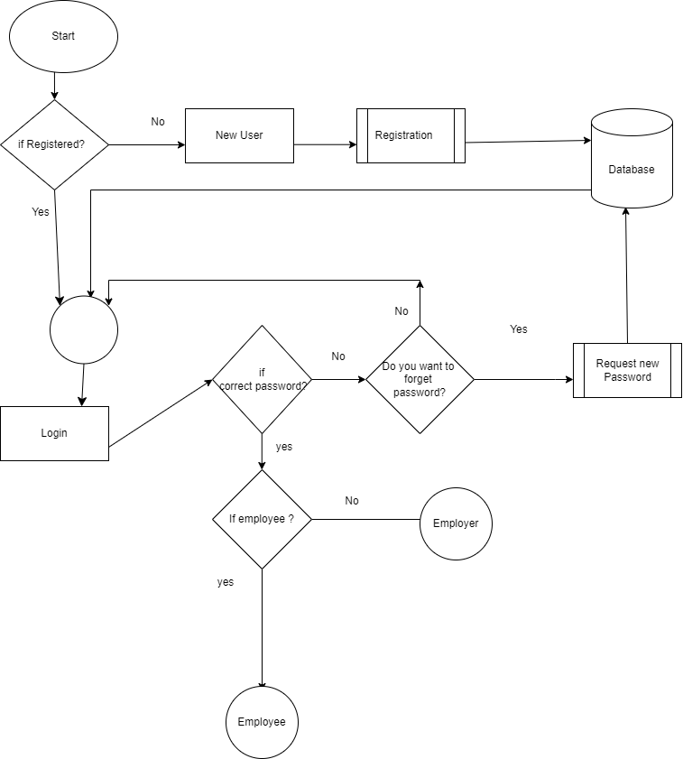

*Figure 3: Flowchart of Authentication*

**Figure 2: Flowchart of Employee**

This flowchart provides a concise overview of how employees interact with the Job Nexus application. It details the main features available to employees, such as exploring jobs, managing their wishlist, updating their profile, reading notifications, and accessing additional information. This structured approach ensures employees have a user-friendly experience while navigating the Job Nexus app.

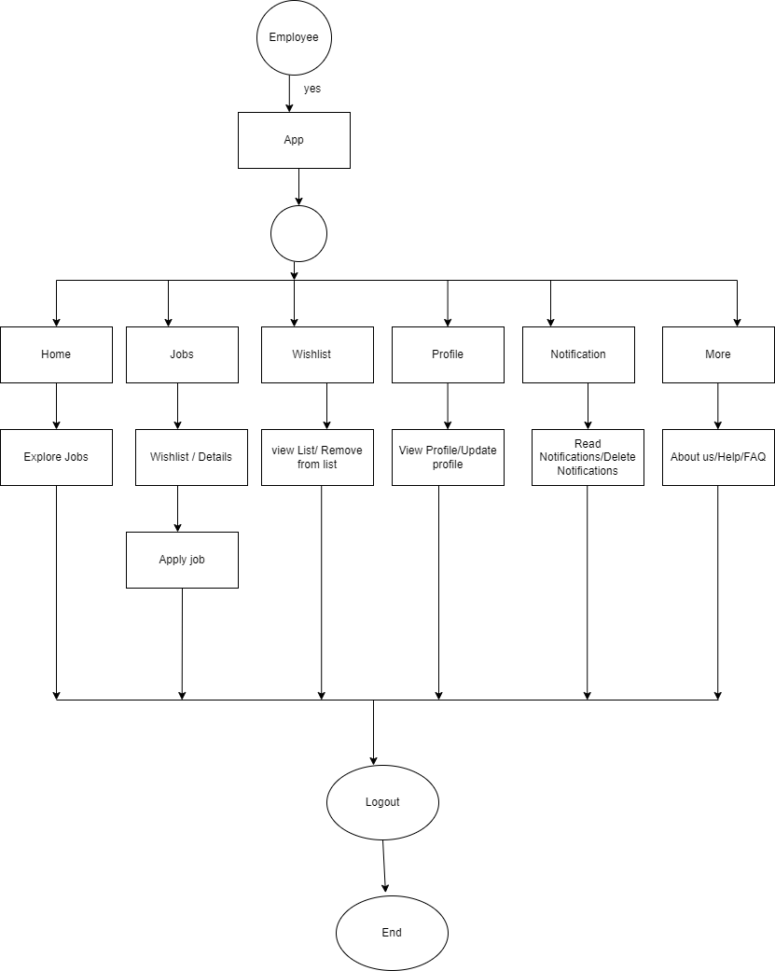

Figure 4: Flowchart of Employee

**Figure 3: Flowchart of Employer**

This flowchart clearly outlines the user journey for employers in the Job Nexus application. It covers the main functionalities available to employers, including posting jobs, managing applications, updating profiles, and handling notifications. The structured approach ensures that employers can efficiently navigate and utilize the app to meet their recruitment needs. 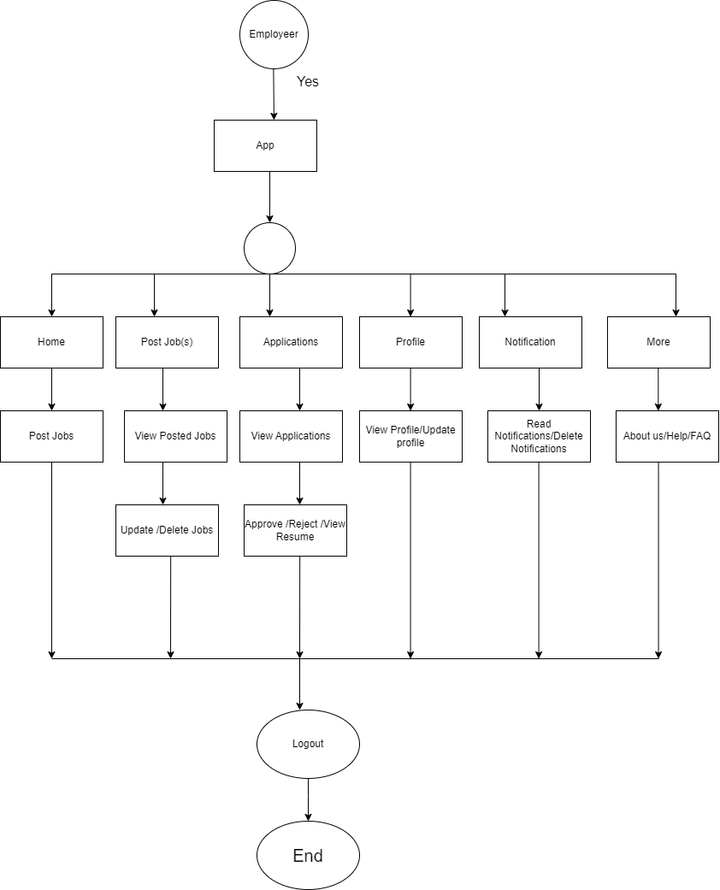

Figure 4: Flowchart of Employer

# GANTT CHART

A Gantt chart is a visual representation of a project's schedule, displaying tasks as horizontal bars along a timeline. It provides an overview of project progress, task dependencies, and helps in tracking project milestones and deadlines.

The Gantt chart for the JobNexus project outlines the timeline and completion status of various tasks from May to July 2024. The project began with initial planning, which was completed in early May. Following this, the requirement analysis phase was also completed in early May. System design was successfully finished by mid-May. The development phase was divided into two parts: Development Phase 1, completed by the mid june and Development Phase 2, completed by mid june. The testing phase followed and was completed by the end of June. Finally, the deployment of the project was successfully carried out in early July. Each task is represented by a bar on the Gantt chart, and all tasks are marked as 100% complete, indicating they were finished within the specified timeline.

The given below is the Gantt chart of our project JobNexus:

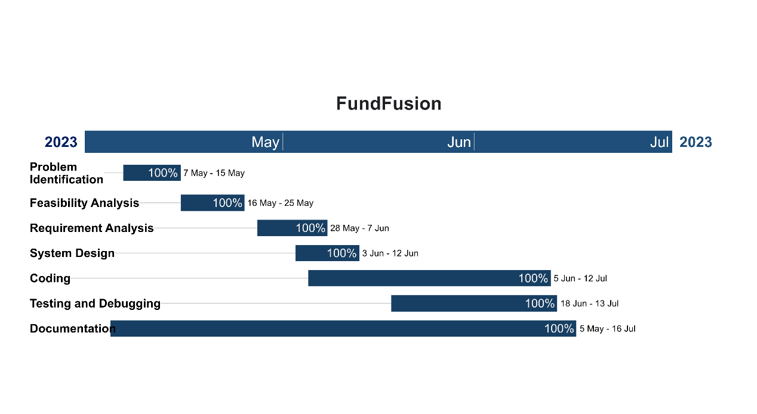

Figure 5: Gantt Chart for FundFusion

# 9. DEVELOPMENT PROCESS

The development phase of the Job Nexus mobile application involved implementing frontend and backend components, integrating necessary APIs, and conducting thorough testing to ensure the application met all specified requirements. Using the Agile model, we engaged in an iterative process that allowed us to adapt to changing needs and prioritize features based on user feedback and market trends. This phase was critical in transforming the initial project scope into a functional, user-friendly app offering a wide range of job listings. The development process was divided into two-week sprints, each with specific goals to complete particular features. Regular sprint planning and retrospective meetings ensured smooth progress. Daily stand-up meetings fostered effective communication and coordination within the team, allowing us to identify and address potential challenges early on. Key features implemented included a company profile section for employers to create job listings and a job search function for employees to find suitable positions based on salary, location, skills, qualifications, and requirements. To maintain code quality and stability, we used continuous integration tools like GitHub, which streamlined code changes and ensured the app was always in a deployable state. while user acceptance testing provided valuable insights for iterative improvements.

In conclusion, the development phase of the Job Nexus app using the Agile model was a collaborative and adaptive process. Through effective sprint planning, user-centric development, continuous integration, and comprehensive testing, we successfully delivered a feature-rich application. This approach not only ensured that we met our project deadlines but also that we provided a high-quality product that meets the needs of both employers and job seekers.

# 10. TESTING

Testing is to make sure that what is created does what it is supposed to do. Testing plays a critical role in assuring the quality and reliability of the software. We have included testing as a part of the development process. The test cases should be designed with maximum possibilities of finding the errors or bugs. We have designed and executed a few test cases to check if the application meets the functional requirements test case comprises a set of conditions or variables employed by a tester to ascertain if a system being evaluated fulfils prescribed requirements or functions correctly. we have executed unit tests on each individual component, confirming their proper functionality before their integration into the larger system.

#### 1. User Registration and Authentication Module

|  |  |  |  |  |  |  |
| --- | --- | --- | --- | --- | --- | --- |
| **Test Case No** | **Test Priority** | **Module Name** | **Test Title** | **Test Executed by** | **Test Reviewed by** | **Pre-condition** |
| 1 | High | User Registration | Register new user | Akriti Chapagain | Binaya Koirala | User not registered |
| 2 | High | User Authentication | Login with valid credentials | Akriti Chapagain | Binaya Koirala | User registered and activated |
| 3 | High | User Authentication | Login with invalid credentials | Akriti Chapagain | Binaya Koirala | None |

|  |  |  |  |  |
| --- | --- | --- | --- | --- |
| **SN** | **Expected Results** | **Test Data** | **Actual Results** | **Status** |
| 1 | User registered successfully | Name:Akriti Chapagain, Email:akriti@gmail.com, Password: Password | Pass | Pass |
| 2 | User logged in successfully and redirected to dashboard | Email: akriti@gmail.com, Password: P@ssw0rd | Pass | Pass |
| 3 | Error message indicating incorrect login details | Email: akriti@gmail.com, Password: wrongpassword | Pass | Pass |

#### 2. Job Listings and Search Module

|  |  |  |  |  |  |  |
| --- | --- | --- | --- | --- | --- | --- |
| **Test Case No** | **Test Priority** | **Module Name** | **Test Title** | **Test Executed by** | **Test Reviewed by** | **Pre-condition** |
| 4 | High | Job Listings | Browse job listings | Akriti Chapagain | Binaya Koirala | User logged in |
| 5 | High | Job Listings | Filter jobs by location | Akriti Chapagain | Binaya Koirala | User logged in |

.

|  |  |  |  |  |  |
| --- | --- | --- | --- | --- | --- |
| **SN** | **Test Case ID** | **Expected Results** | **Test Data** | **Actual Results** | **Status** |
| 4 | TC-JS-03 | Job listings filtered by location | Location: Kathmandu | Pass | Pass |
| 5 | TC-JS-04 | Job listings filtered by location | Industry: IT | Pass | Pass |

***3*. Profile Management Module**

|  |  |  |  |  |  |  |
| --- | --- | --- | --- | --- | --- | --- |
| **Test Case No** | **Test Priority** | **Module Name** | **Test Title** | **Test Executed by** | **Test Reviewed by** | **Pre-condition** |
| 6 | High | Profile Management | Create employee  Profile | Akriti Chapagain | Binaya Koirala | User logged in |
| 7 | High | Profile Management | Update  Employee profile | Akriti Chapagain | Binaya Koirala | User logged in |
| 8 | High | Profile Management | Create employer profile | Akriti Chapagain | Binaya Koirala | User logged in |
| 9 | High | Profile Management | Update employer profile | Akriti Chapagain | Binaya Koirala | User logged in |

|  |  |  |  |  |
| --- | --- | --- | --- | --- |
| **SN** | **Expected Results** | **Test Data** | **Actual Results** | **Status** |
| 6 | Profile created successfully | Profile Data: {Name, Email, Address, etc.} | Pass | Pass |
| 7 | Profile updated successfully | Updated Data: {Name, Email, Address, etc.} | Pass | Pass |
| 8 | Employer profile created successfully | Employer Data: {Company Name, Industry, etc.} | Pass | Pass |
| 9 | Employer profile updated successfully | Updated Data: {Company Name, Industry, etc.} | Pass | Pass |

**4.** **Create Job**

|  |  |  |  |  |  |  |
| --- | --- | --- | --- | --- | --- | --- |
| **Test Case No** | **Test Priority** | **Module Name** | **Test Title** | **Test Executed by** | **Test Reviewed by** | **Pre-condition** |
| 11 | High | Job Management | Create job | Akriti Chapagain | Binaya Koirala | User logged in, employer |

|  |  |  |  |  |
| --- | --- | --- | --- | --- |
| **SN** | **Expected Results** | **Test Data** | **Actual Results** | **Status** |
| 10 | Job created successfully | Job Data: {Title, Description, Salary, etc.} | Pass | Pass |

#### 5. Job Apply

|  |  |  |  |  |  |  |
| --- | --- | --- | --- | --- | --- | --- |
| **Test Case No** | **Test Priority** | **Module Name** | **Test Title** | **Test Executed by** | **Test Reviewed by** | **Pre-condition** |
| 12 | High | Application Management | Apply for job | Akriti Chapagain | Binaya Koirala | User logged in |

|  |  |  |  |  |
| --- | --- | --- | --- | --- |
| **SN** | **Expected Results** | **Test Data** | **Actual Results** | **Status** |
| 12 | Job application submitted | Application Data: {Job ID, Applicant ID, etc.} | Pass | Pass |

**6. Application Retrieval**

|  |  |  |  |  |  |  |
| --- | --- | --- | --- | --- | --- | --- |
| **Test Case No** | **Test Priority** | **Module Name** | **Test Title** | **Test Executed by** | **Test Reviewed by** | **Pre-condition** |
| 13 | High | Application Management | Retrieve job applications | Akriti Chapagain | Binaya Koirala | User logged in, employer |

|  |  |  |  |  |
| --- | --- | --- | --- | --- |
| **SN** | **Expected Results** | **Test Data** | **Actual Results** | **Status** |
| 13 | Applications retrieved successfully | Job ID, Employer ID | Pass | Pass |

**7. Wishlist**

|  |  |  |  |  |  |  |
| --- | --- | --- | --- | --- | --- | --- |
| **Test Case No** | **Test Priority** | **Module Name** | **Test Title** | **Test Executed by** | **Test Reviewed by** | **Pre-condition** |
| 14 | Medium | Wishlist | Add job to wishlist | Akriti Chapagain | Binaya Koirala | User logged in |
| 15 | Medium | Wishlist | Remove job from wishlist | Akriti Chapagain | Binaya Koirala | User logged in |

|  |  |  |  |  |
| --- | --- | --- | --- | --- |
| **SN** | **Expected Results** | **Test Data** | **Actual Results** | **Status** |
| 1 | Job added to wishlist successfully | Job ID, User ID | Pass | Pass |
| 15 | Job removed from wishlist successfully | Job ID, User ID | Pass | Pass |

**8. Search**

|  |  |  |  |  |  |  |
| --- | --- | --- | --- | --- | --- | --- |
| **Test Case No** | **Test Priority** | **Module Name** | **Test Title** | **Test Executed by** | **Test Reviewed by** | **Pre-condition** |
| 15 | High | Job Management | Search jobs | Akriti Chapagain | Binaya Koirala | User logged in |

|  |  |  |  |  |
| --- | --- | --- | --- | --- |
| **SN** | **Expected Results** | **Test Data** | **Actual Results** | **Status** |
| 15 | Jobs retrieved based on search criteria | Search Criteria: {Keywords, Location, etc.} | Pass | Pass |

## 11. Project Result(with demo)

Finally, after following the software development lifecycle and completing the testing phase, we successfully implemented the Job Nexus project. Some features are still under development and will be included in future enhancements. This section highlights the results based on the following:

**I. Functions Achieved by Our Project**

The Job Nexus application successfully implements the following functions:

Easy Browsing: Users can easily browse and select specific jobs from the available options.

Job Application: Allows job seekers to apply for jobs directly through the application with a few clicks.

Job Posting: Enables employers to post job vacancies, specifying job details such as title, description, requirements, salary range, and location.

Job Seeker Profiles: Enables job seekers to create, update, and manage their profiles, including personal details, education, work experience, and skills.

Employer Profiles: Allows employers to create and update company profiles, including company details, contact information, and descriptions.

Password Recovery: Provides functionality for users to recover forgotten passwords.

User Authentication: Ensures secure login with authentication for enhanced security.

Secure Registration: Allows both job seekers and employers to register by providing necessary details.

Wishlist Management: Allows job seekers to add jobs to their wishlist for future reference and easy access.

Application Status Tracking: Enables job seekers to track the status of their job applications (e.g., applied, under review, accepted, rejected).

Application Management: Allows employers to manage and update the status of applications received, facilitating efficient recruitment processes.

User Account Management: Admins can manage user accounts, including activation, deactivation, and access permissions.

Content Management: Admins can verify, approve, and manage job postings and other content on the platform.

**II. Problems Solved by the Project**

The Job Nexus application addresses several key problems in the job market, providing solutions that benefit both job seekers and employers:

Bridging the Gap: The application bridges the gap between job seekers and job providers, especially for semi-skilled workers and those in rural areas who often face difficulties accessing job opportunities.

Diverse Opportunities: It offers a platform that caters to job seekers with varying levels of skills and experience, including those seeking entry-level positions and volunteer opportunities.

Simplified Job Search: The advanced search and filtering options make it easier for job seekers to find relevant job opportunities, reducing the time and effort required to search for jobs.

Streamlined Application Process: The ability to apply for jobs directly through the application simplifies the application process for job seekers, while employers benefit from a streamlined recruitment process.

Enhanced Security: The application implements robust security measures, including data encryption to protect user data and ensure privacy.

Secure Data Management: Ensures that personal information, resumes, and application details are securely stored and managed.

Professional Resumes: The built-in resume generator produces professional-quality resumes, addressing the issue of overly basic resumes produced by other systems.

Easy Profile Management: Users can easily create, update, and manage their profiles, ensuring that their information is always up-to-date and relevant.

Status Tracking: Job seekers can track the status of their applications, providing them with visibility into the recruitment process and reducing anxiety related to the job search.

Efficient Application Management: Employers can efficiently manage and update the status of applications received, facilitating better communication with job applicants.

Content Verification: Admins can verify and approve job postings, ensuring that only legitimate and high-quality job listings are available on the platform.

User Account Management: Admins can manage user accounts, ensuring proper access controls and maintaining the platform's integrity.

In summary, Job Nexus has successfully delivered a comprehensive and user-centric job search platform that offers a seamless experience for both job seekers and employers. With its intuitive interface, accurate recommendations, efficient search capabilities, and robust security measures, Job Nexus is poised to make a significant impact on the job market in Nepal, promoting inclusivity, accessibility, and economic empowerment.

**12. Future Enhancement**

Future enhancements in JobNexus refer to potential improvements and additional features that can be incorporated into the application to enhance its functionality, usability, and overall user experience. As technology evolves and user needs change, continuous development and improvement are essential to keep the platform relevant and competitive. Here are some possible future enhancements for JobNexus:

Several future enhancements can be considered:

* **Localization and Language Support**

Expand language support to cater to a broader audience, including localizing the platform for different regions and languages.

* **Social Media Integration**

Integrate with social media platforms to allow users to share job postings and application statuses, as well as apply through social media profiles (e.g., LinkedIn).

* **User Feedback and Continuous Improvement**

Regularly collect feedback from users to identify pain points and areas for improvement. Use this feedback to make continuous enhancements to the platform.

* **Employer Branding:** Provide companies with tools to enhance their employer brand, including the ability to showcase their company culture through photos, videos, and employee testimonials. This can attract more qualified candidates.
* **Mobile Application Enhancements**

Improve the mobile application with features such as: Offline access to job listings and applications, Push notifications for job alerts and updates Seamless integration with calendars for interview scheduling

* **Skill Development and Training Integration:** Integrate online courses, certifications, and training programs to help job seekers improve their skills and increase their employability. This can include partnerships with e-learning platforms like Coursera, Udemy, or LinkedIn Learning.
* **Real-time Chat Support**: Implement real-time chat support to provide users with instant assistance and guidance throughout their job search journey. This could include chatbots for basic queries and live chat support for more complex issues.
* **Interview Preparation Resources:** Offer interview preparation resources, including tips, sample questions, and mock interview simulations. Empowering users with the tools they need to succeed in interviews can improve their confidence and chances of landing their desired roles.

**13. Conclusion**

In conclusion, JobNexus, a Job Portal Android app, can yield numerous benefits for both Job seekers and Employer, we have successfully developed a robust and user-friendly

online job portal that addresses the needs of job seekers and employers alike. The

development journey has been a collaborative effort, marked by challenges, learnings, and continuous improvement. The project's achievements lie not only in the tangible outcomes but also in the invaluable learnings gained throughout the process. We have used our skills in development, incorporating best practices in system analysis, design, and implementation. The utilization of an object-oriented approach, as evidenced by Diagrams, such as ER, DFDs, Flowcharts, has enhanced the project's structural integrity and functionality.

Moreover, the collaborative nature of GitHub, project played an important role in coordinating our efforts seamlessly, resulting in transparent communication and effective version control. As we conclude this project, we carry forward not only a fully functional job portal but a wealth of experiences. The journey has equipped us with a deeper understanding of software project development, project management, and the significance of addressing economic considerations. The adoption of agile methodology aligns seamlessly with the development of JobNexus, proving to be an ideal fit for its app development process. With Agile, the team can enjoy the flexibility to adapt to changing requirements, employ iterative development cycles to continuously improve the app, and promote effective collaboration among team members. Consequently, agile methodology can accelerate the development timeline, leading to a faster time-to-market for JobNexus. A well-designed and user- friendly app can significantly enhance the overall customer experience, leading to increased user satisfaction and loyalty.

These learnings will surely shape our approach to future projects, allowing us to navigate challenges with confidence and innovation.

# DATABASE SCHEMA:

A database schema is a logical structure that defines the organization and representation of data in a database. It serves as a blueprint or framework for designing and creating the database.

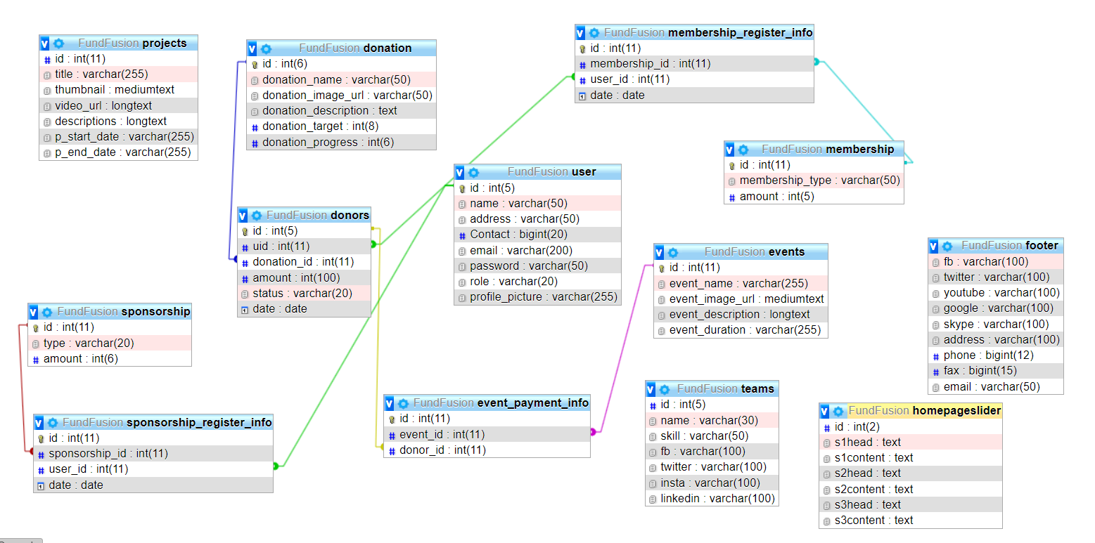

Figure 6: Database Schema for FundFusion

# TESTING METHODOLOGY

Our testing methodology follows the Agile Testing Lifecycle, enabling collaborative testing to ensure the functionality and performance of the Anime Archive website.

Here are the key phases of the “Agile Testing Life Cycle”;

* Test Planning: During this phase, we gather requirements, define test objectives, and create a high-level test plan. Our focus is on understanding the project scope and establishing test strategies.
* Test Design: In this phase, we develop detailed test cases and test scenarios based on the project requirements. We also define test data and expected results. Our goal is to design comprehensive and effective tests.
* Test Execution: This phase involves carrying out the actual testing activities. We execute the test cases, log defects when issues are found, and record test results. Our testing covers both functional and non-functional aspects based on the defined test cases.
* Test Reporting: During this phase, we analyse the test results, track defects, and generate test reports. These reports provide stakeholders with an overview of the testing progress, including the number of executed test cases, the number of defects discovered, and the overall software quality.

# PROJECT RESULTS

The FundFusion project holds the potential to achieve significant positive outcomes in the realm of charitable activities. Based on its design and planned features, the project anticipates the following results:

* Anticipated Increase in Donation Rate: The implementation of secure payment gateways, such as Khalti and eSewa, is expected to provide a convenient and trusted platform for donors to contribute to various events and causes. This is likely to result in an increased donation rate.
* Enhanced Donor Engagement: With the planned implementation of the Donor Details page, donors will have the ability to track and monitor their past support to the organization. This feature aims to foster transparency and accountability, strengthening the connection between donors and the organization. It is anticipated that this increased engagement will lead to a stronger commitment to the organization.
* Active Volunteer Participation: The Volunteer Program, once implemented, is expected to attract individuals who are passionate about giving back to the community. By offering opportunities for users to actively participate in charitable events and initiatives, the program aims to mobilize volunteers and leverage their skills to amplify the organization's impact.
* Enthusiasm for Membership Program: The Membership Program, featuring different tiers (Silver, Gold, and Platinum), aims to foster donor loyalty and incentivize ongoing support. Anticipated benefits and exclusive access to events, resources, and recognition are expected to generate enthusiasm among donors
* Positive User Experience: The planned user-friendly interface, seamless navigation, and responsive design of the FundFusion portal are expected to create a positive user experience. It is anticipated that visitors will find it easy to access information, explore various sections, and complete donation processes with minimal friction.

# FUTURE ENHANCEMNTS

* Integration of international payment gateways: Incorporating additional payment options like PayPal to facilitate donations from a global audience, expanding the reach and accessibility of the website.
* Simplified sign-up process using social media APIs: Streamlining user registration by allowing users to sign up or log in using their existing social media accounts, reducing barriers to entry and encouraging greater user participation.
* Implementation of badges and donor recognition: Introducing a badge system or recognition program to reward and acknowledge donors based on their cumulative contributions, fostering a sense of achievement and motivating continued support.
* Dedicated section for showcasing donor impact: Creating a specific section to showcase the stories and testimonials of donors, highlighting the tangible impact of their donations and creating a stronger sense of community and appreciation.
* Incorporation of a section for success stories and activities: Designating a dedicated space to showcase success stories, past activities, and initiatives, providing transparency, credibility, and demonstrating the effectiveness of the organization's efforts, further engaging visitors and encouraging continued support.

# CONCLUSION

FundFusion's success lies in its commitment to providing an effective and user-friendly platform for supporting charitable causes. The project's development involved the collaborative efforts of a dedicated team, utilizing PHP as the back-end and Bootstrap as the front-end tool. With the aim of streamlining charitable activities, FundFusion offers various functionalities and features that empower end-users to make a positive impact. One notable aspect of FundFusion is its emphasis on secure payment options. By integrating trusted platforms such as Khalti and eSewa, the portal ensures that donors can contribute to various events and causes with peace of mind. The secure payment process eliminates barriers and encourages individuals to support charitable initiatives, knowing that their transactions are safe and protected.

The Donor Details page is another valuable feature that sets FundFusion apart. This functionality allows donors to track their past support to the organization, providing transparency and accountability. Donors can conveniently access information about their contributions, fostering a sense of trust and confidence in the charitable process.

Moreover, FundFusion goes beyond monetary contributions by offering a Volunteer Program and a Membership Program. The Volunteer Program allows users to actively participate in events and initiatives, giving them a tangible way to make a difference through their time and skills. The Membership Program, with its three options (Silver, Gold, and Platinum), offers exclusive benefits to members, encouraging long-term engagement and loyalty. FundFusion's integrated session functionality and well-designed database contribute to a seamless user experience. The flexibility of authentication through login enables users to navigate multiple pages within the admin portal, further enhancing the platform's usability and convenience.

In summary, FundFusion stands as an effective and user-friendly web portal that enables individuals to support charitable causes. With its focus on secure payments, donor tracking, volunteer engagement, and membership benefits, FundFusion provides a comprehensive platform for users to donate, participate, and actively contribute. The project's success lies in its commitment to streamlining charitable activities and empowering individuals to make a meaningful impact in the community..

# REFRENCES

* [1] D. Cyr, "Modeling website design across cultures: Relationships to trust, satisfaction, and e-loyalty," Journal of Management Information Systems, vol. 20, no. 4, pp. 109-134, 2004.
* [2] L. M. McInnis, K. Nakamoto, and L. Helfer, "The value of good governance: Nonprofit governance and public perceptions of charitable organizations," Public Performance & Management Review, vol. 35, no. 4, pp. 611-636, 2012.
* [3] M. C. Saaksjarvi and S. Lassila, "Donation intentions: The role of financial information, emotions, and values," Journal of Consumer Marketing, vol. 28, no. 4, pp. 305-315, 2011.
* [4] A. I. Nicolaou and D. H. McKnight, "Perceived information quality in data-exchange relationships: Impact on interorganizational system usage," MIS Quarterly, vol. 25, no. 4, pp. 669-694, 2001.
* [5] Y. Song and F. M. Zahedi, "An empirical study of website navigation structures' impact on website usability," AMCIS 2003 Proceedings, paper 82, 2003.
* [6] R. D. Waters, "Test of a model of charity support behavior," Journal of Nonprofit & Public Sector Marketing, vol. 11, no. 3, pp. 45-64, 2003.
* [7] D. D. Frink, M. L. Doerfel, and R. B. Rubin, "Corporate mission statements as rhetorical genre: Implications for impression management," Journal of Business Communication, vol. 42, no. 2, pp. 151-172, 2005.

# ANNEX

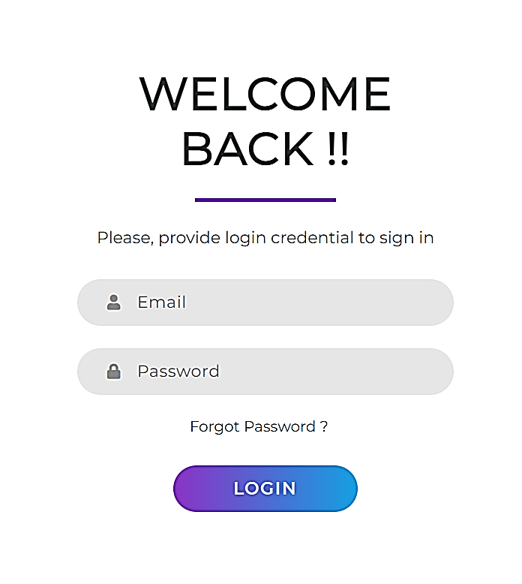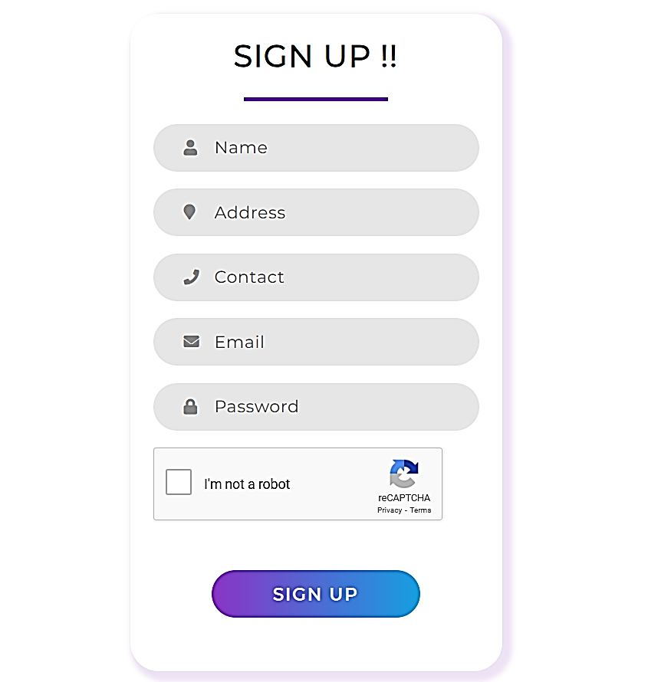



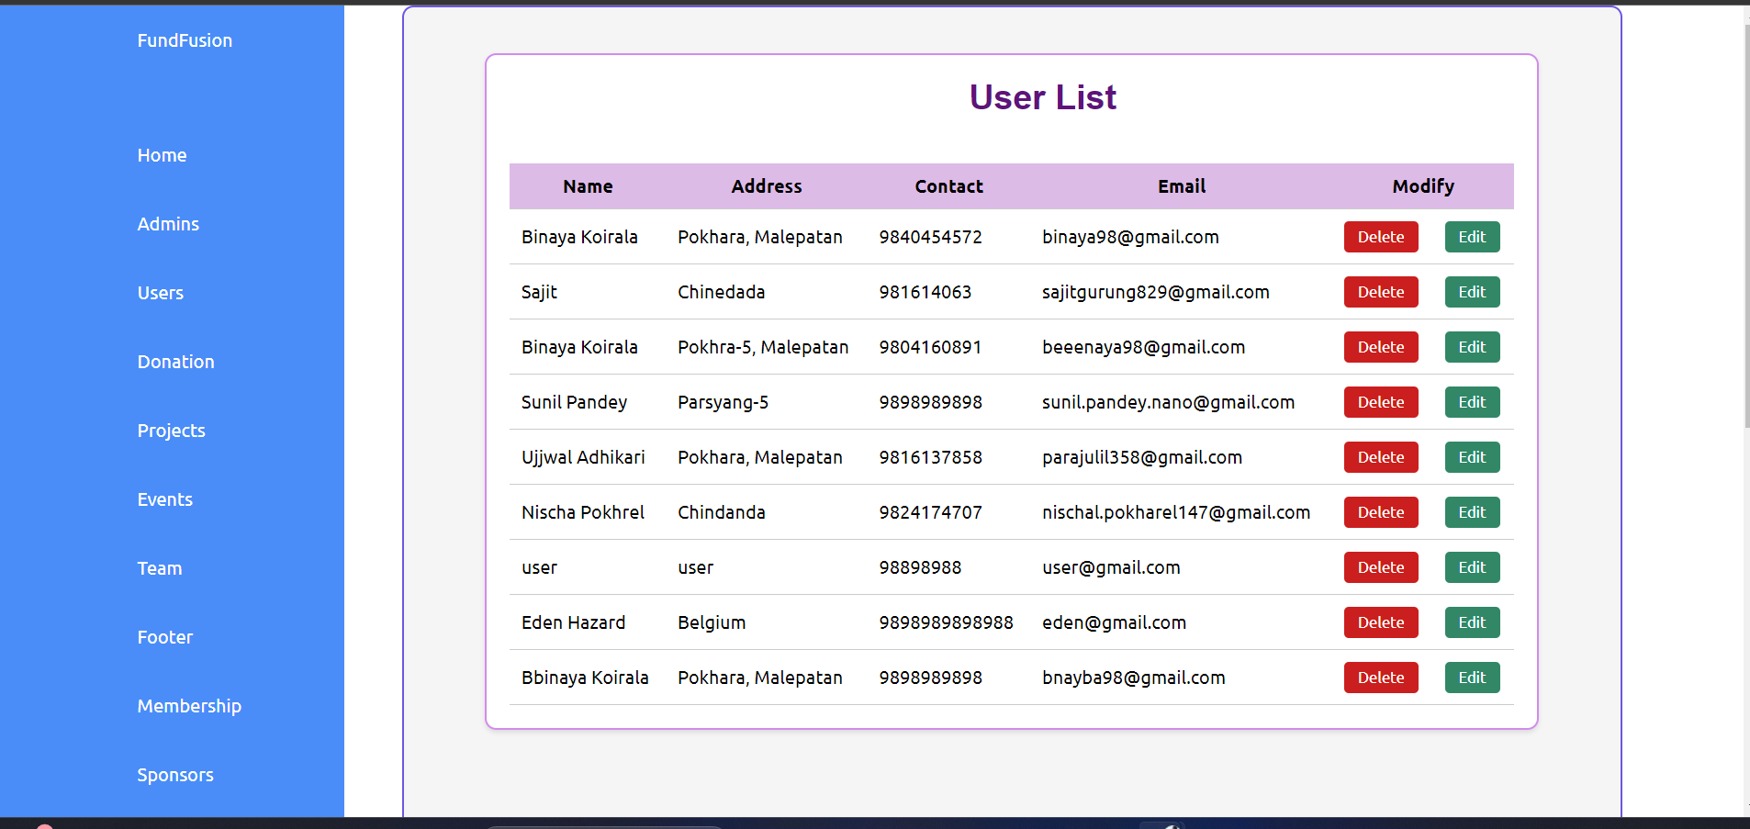

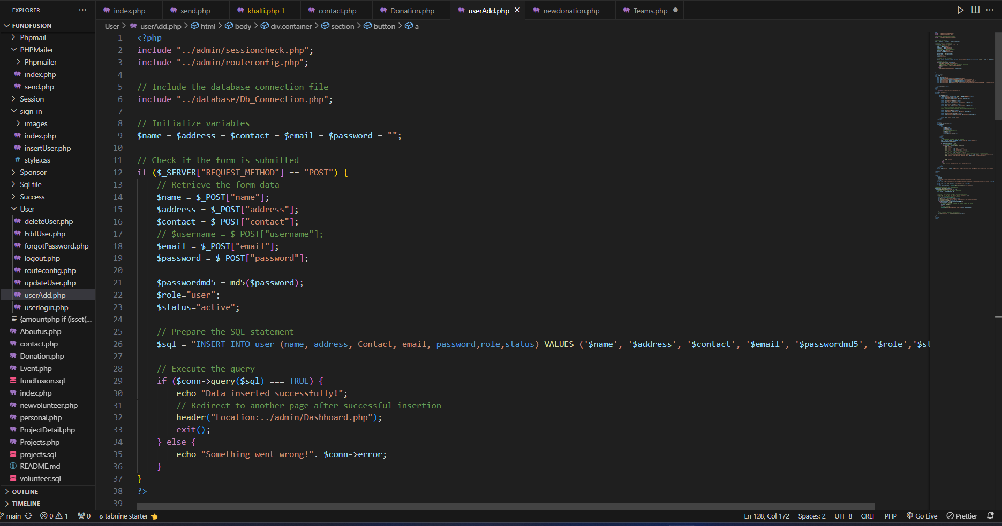

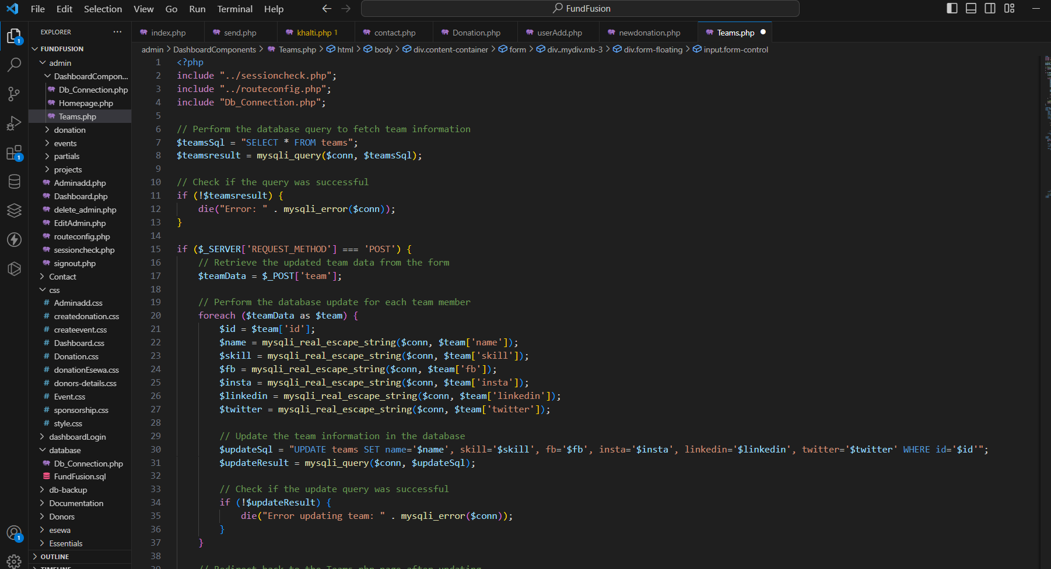

# TEST CASES

|  |  |  |  |  |
| --- | --- | --- | --- | --- |
| **Test Case ID** | **Test Case** | **Test Steps** | **Test Data** | **Results** |
| TC001 | User Registration | 1. Open the browser 2. Enter the URL: localhost/FundFusion/index.php 3. Fill the sign up form. 4. Registration complete | User information. | The user is registered successfully. |
| TC002 | Login Check | 1. Login as a user 2. Session implementation. 3. User information is displayed. | Users login data. | The user is able to login successfully. |
| TC003 | User donation | 1. Login verification. 2. Choose donation portal. 3. Fill donation form from session. 4. Enter donation amount and continue. | User information from session and donation amount. | The user can donate successfully. |
| TC004 | Admin manages user | 1. Login as an admin 2. Navigate to the user management section 3. Search for an existing user 4. Update the user's information (e.g., change role) | Existing user details’ | The user's information is updated successfully. |
| TC005 | Admin manages donation. | 1. Login as an admin 2. Navigate to the donation portal. 3. Modify/Add/Delete the donation portal. | Donation portal information. | The donation portal changes accordingly. |
| TC006 | Signup Information on mail | 1. Navigate to the signup 2. Enter Details 3. Successful Registration informed with mail | User information. | Mail was sent to tbe User |
| TC007 | Forgot Password | 1. Navigate Login Section. 2. Click Forgot Password and enter registered mail. 3. Password is sent on mail. | User Email. | User receives new password on mail |
| TC008 | Donation Progress Bar | 1. Donation as User. 2. Increases the Donation progress. | Donor information and Details | Donation Progress is seen. |